Barberton – Norton Mosquito Abatement District
2025 Annual Report

I. Surveillance
Gravid traps and EVS light traps were set throughout Norton and Barberton between May 19 and September 26, 2025. The mosquitoes collected from the gravid traps were frozen, identified, counted and contained in vials with no more than 50 specimens per vial and sent on a weekly basis to the Ohio Department of Health in Reynoldsburg, Ohio to be tested for diseases. A total of 37,358 mosquitoes were captured in the gravid traps. This amount compares to the previous year of 2024 which 19,930 mosquitoes were trapped for testing. We attribute this to a change in our larvicide program which was started the first of April in 2017 and using GPS images to find new areas that were breeding mosquitoes. Of the pools tested, 112 were found to contain mosquitoes testing positive for the West Nile Virus. This compares to 15 positive pools in 2024. This increase in number of positive pools was consistent across the state of Ohio and the Midwest. Although this is by far the highest number of confirmed positive pools the district has ever had, BNMAD had a lower percentage of positive samples than most other contributing districts and health departments around the state. The mosquito pools that were reported positive were collected in the following areas:

Coordinates |  | Trap ID |  | Dates Collected 2025
Latitude | Longitude
41.0338 | -815869 | 101 |  | 7/11/25, 8/7/25, 8/14/25, 8/19/25
41.061 | -81.5721 | 102 |  | 7/3/25, 7/11/25, 7/18/25, 7/23/25, 7/29/25, 8/7/25, 8/14/25, 8/19/25, 9/3/25
40.9807 | -815971 | 103 |  | 6/26/25, 6/27/25, 7/18/25, 7/29/25, 8/7/25, 8/19/25, 9/12/25
41.0285 | -81.6071 | 104 |  | 6/12/25, 6/27/25, 7/18/25, 7/23/25, 8/7/25, 8/14/25, 8/19/25, 9/17/25
41.0162 | -81.63 | 105 |  | 7/11/25, 7/29/25, 8/7/25, 8/14/25, 8/19/25
40.9979 | -81.6307 | 106 |  | 7/18/25, 7/23/25, 7/29/25, 8/7/25, 8/14/25
41.0623 | -81.614 | 201 |  | 7/18/25, 7/23/25, 7/29/25, 8/7/25, 8/19/25
41.0622 | -81.6001 | 202 |  | 7/18/25, 8/7/25, 8/14/25, 8/19/25, 8/29/25, 9/12/25, 9/19/25
41.0333 | -81.6599 | 203 |  | 7/11/25, 7/18/25, 7/23/25, 8/7/25, 8/14/25
41.0049 | -81.6599 | 204 |  | 6/25/25, 6/27/25, 7/11/25, 7/18/25, 7/29/25, 8/14/25, 9/3/25, 9/12/25, 9/19/25

Following notification of pools containing the West Nile Virus, BNMAD notified residents in those areas, along with newspapers and local authorities, so all residents were reminded of the proper procedures to protect themselves and help eliminate the spread of the disease. BNMAD then aggressively targeted those areas with additional surveillance, larviciding (larviciding prevents the larvae from becoming adult mosquitoes) and adulticiding (spraying). Adulticiding is the only way to eliminate the adult mosquito that carries the West Nile Virus and other diseases.

II. Surveillance, EVS Light Traps, Gravid Traps and BG Sentinel Traps
Light and Gravid traps were set throughout the BNMAD. EVS Light Trap counts are used to determine the night time activities of biting mosquitoes. If counts are extremely low, then that area would not need to be adulticided at that time. Issues that also determine whether an area should be adulticided are factors such as complaints from residents and whether the West Nile Virus has been found in that area.

Gravid traps are set Monday through Thursday. They attract the mosquitoes from dusk to dawn. These are collected in the mornings Tuesday through Friday. As explained previously, they are identified, frozen and sent for testing to determine the presence of the West Nile Virus and other diseases. The number of mosquitoes trapped in Gravid traps in Norton was 13,464 and 23,894 in Barberton for a total of 37,358 in the district.

In the City of Norton, 13 EVS light traps were set bi-weekly. In the City of Barberton 18 EVS Light traps were set bi-weekly.

In Norton, there were 280 mosquitoes collected and Barberton had 1,585 for the season by the EVS light traps. This is a total of 1,865.

In 2022, we discontinued our surveillance to trap the Aedes albopictus which is a carrier of the Zika virus. We came to this decision to not put the BG Sentinel traps out this year after discussion with the Ohio Department of Health. The main factors in this decision were that there had been no reported Zika cases in Ohio in almost 5 years and that we had only found 3 Aedes albopictus in the BG Sentinel traps all of 2021, from May to September. We will continue to discuss this with the Department of Health every year and redeploy the BG Sentinel traps if/when they advise us to. For more info on Zika Virus go to https://odh.ohio.gov/know-our-programs/zoonotic-disease-program/diseases/zika.

III. Mosquito Species and Disease
The most common specie found in the BNMAD is the Culex mosquito. There are 64 species of mosquitoes in Ohio with only several that spread diseases. Diseases that affect humans carried by the mosquito in Ohio are LaCrosse Encephalitis (LCE), St. Louis Encephalitis (SLC) and West Nile Virus (WNV). Diseases that affect animals are heartworm in dogs and cats, Eastern Equine Encephalitis Virus (EEEV) in horses. Unfortunately, the types of mosquitoes that are spreading diseases are changing and keeping educated and up to date on this topic is extremely important. The BNMAD continues to take aggressive actions to locate areas where heartworm disease was found. We are doing a better job of following up on reports of heartworm, as our pets are so important and beneficial to the residents and we want to protect them as well.

IV. Communication

a. Education/Newspaper Articles/Website
The BNMAD program conducts an Integrated Mosquito Management Program (IMM). This includes 4 major components.

First, and most important, is EDUCATION.

The BNMAD has many programs that we use to educate the public of how they can help control the mosquito population. Our website, www.mosquitodistrict.com, contains many articles how to accomplish this. Facebook has also become a popular site for anyone to keep informed of any mosquito information we share. Articles that tell what repellent to use, what attracts mosquitoes and how to reduce the amount, types of mosquitoes, disease symptoms and many more useful articles. It also includes all the results of the testing for the WNV and what areas are affected. The schedules for spaying and the Board of Director meetings are posted and updated regularly. Much of this information is also shared in the local newspapers. Much of this information is shared with local newspapers, many times on a weekly basis, throughout the season. Also, we keep the local government entities informed. The BNMAD spoke at several workshops, training sessions where we presented our programs services and results plus answered questions that anyone wished to present. We conducted several workshops with area scouts, church groups and civic organizations and educating all attending how to help reduce the mosquito population and explain the diseases they carry. In short, No Eggs – No Larvae – No Mosquitoes!
Interviews were given to several newspapers including The Barberton Herald, Akron Beacon Journal, The Columbus Dispatch and The Norton Post.

The second part of the program is Surveillance

We use EVS Light Traps and Gravid Traps to allow us to know of any problems with mosquitoes.

EVS light Traps are hung from trees in the late evening. The top of the trap contains dry ice. Dry ice emulates our breath. Our breath is made of C02 which is what the dry ice contains. There is also a small light in the traps. These two items attracts the mosquito and are caught in the net that hangs from the bottom of the trap. They are forced into the net with a small battery operated fan. We gather the traps the next morning and count the amount of mosquitoes. If the counts are above what we feel is acceptable, we then determine whether there is a need to spray that area. The mosquitoes trapped in the light traps are not sent for testing of diseases.
Gravid Traps are set out four days a week. It consists of a basin of “stinky” water with a battery operated fan that forces the mosquitoes that are attracted to the water, into a net that is placed on top of the trap. Each morning we gather the nets, freeze, count, identify, put into vials and send to the lab for testing. We have them tested for the West Nile Virus. If any are found to be positive for WNV we then notify the residents and target that area aggressively to reduce the mosquito population.

The third part of the IMM program is LARVICIDING

Larviciding involves treating any area where mosquitoes are breeding or have the potential to breed. Elimination of the larvae or pupae to develop into an adult mosquito is very important. The more we prevent the larvae/pupae from evolving into adults, the less chance of the mosquitoes becoming a nuisance or spreading disease. The products used for larviciding are environmentally friendly and are purchased from both the Univar and Clarke companies who are among the top companies in this field. The goal is to eliminate the larvae or pupae before they become adults.

The fourth part of the IMM program is ADULTICIDING

Adulticiding is what most residents’ notice, which is SPRAYING. Once mosquitoes reach the adult stage, spraying is the only way to reduce their population. It’s the last line of defense and what we spend the least amount of our time conducting because our attention is focusing on preventing mosquitoes from becoming adults, which helps lower the need for spraying.

b. Telephone Calls:

BNMAD receive many calls from residents and businesses of the district concerning field operations. Most calls were received starting in March and continued throughout the season. In addition, calls came from local government entities, newspapers, television stations and businesses.
Residents reported to us when there were excess mosquitoes in their area. This is very helpful in being able to find problem areas and reduce the mosquito population and lowering the chances of diseases spreading. We respond and inspect the area for any standing water, tree holes or high vegetation where mosquitoes may be breeding. If something is found, we use the appropriate application to remedy the problem. Residents also call to schedule a special treatment if they are hosting an outdoor event such as graduation parties, weddings or any other occasion. Each property owner is entitled to one special treatment per year.
Businesses request special sprayings when the mosquitoes start affecting their finished products or have the potential to affect them, and most importantly, the safety of their employees. Businesses need to be addressed immediately as they employee many and the BNMAD concerns are not only to the physical health of employees, which is the most important, but to the financial health of the businesses and communities we service.
We also take great care of those who call to make sure parks and sporting facilities are being treated so the participants and spectators may enjoy the event. The calls are usually not necessary as these areas are on our regular schedule for being treated, but we do welcome and respect their concerns as they keep us up to date on the conditions in our area.

C. Barberton – Norton – Summit and Surrounding Counties
The BNMAD keeps local entities informed of our status and any problems that may arise with the diseases spread by mosquitoes.
They were also notified that in the future we are taking a more active approach with helping to eliminate areas with water problems that contribute to the mosquito population.

2025 Numbers At-A-Glance
As of December 11, 2025
Leeanne C. Garrett, MPH-VPH
Public Health Entomologist
Bureau of Infectious Diseases
Zoonotic Disease Program, Ohio Department of Health

2025 Mosquito-borne Diseases
West Nile Virus
Mosquito surveillance:
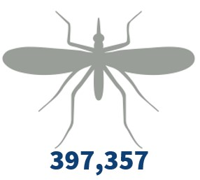
Mosquitoes tested from 58 agencies in 49 counties, pooled into 11,980* samples.
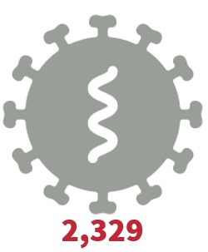
West Nile virus positive mosquito pools from 42 counties:
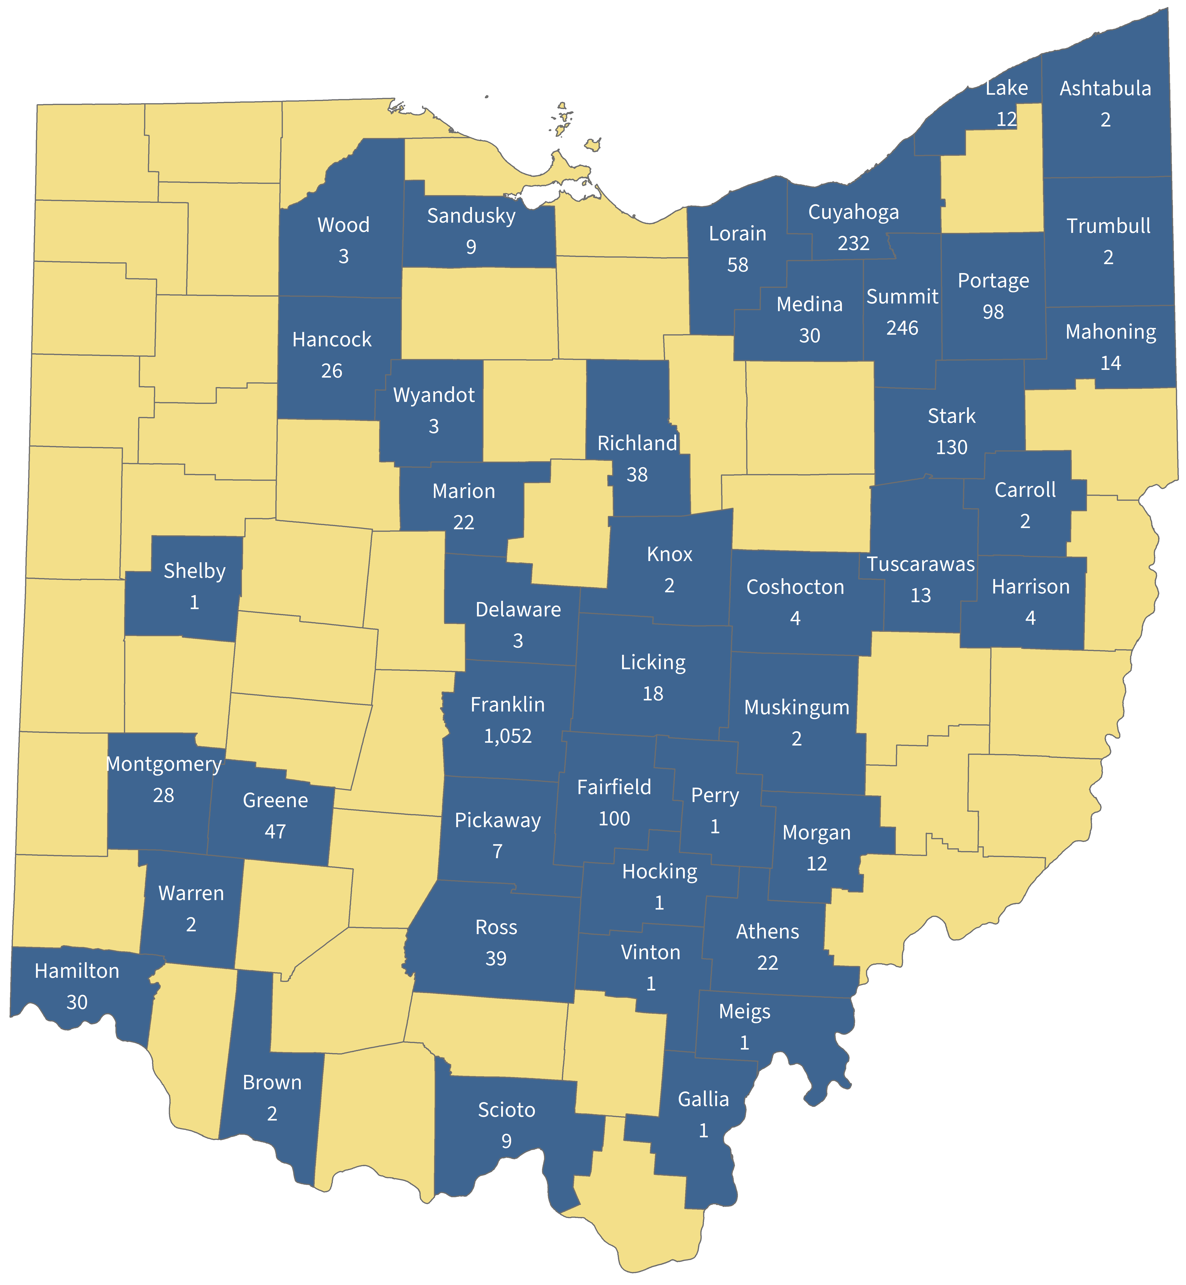
Ashtabula (2), Athens (22), Brown (2), Carroll (2), Coshocton (4), Cuyahoga (232), Delaware (3), Fairfield (100), Franklin (1,052), Gallia (1), Greene (47), Hamilton (30), Hancock (26), Harrison (4), Hocking (1), Knox (2), Lake (12), Licking (18), Lorain (58), Mahoning (14), Marion (22), Medina (30), Meigs (1), Montgomery (28), Morgan (12), Muskingum (2), Perry (1), Pickaway (7), Portage (98), Richland (38), Ross (39), Sandusky (9), Scioto (9), Shelby (1), Stark (130), Summit (246), Trumbull (2), Tuscarawas (13), Vinton (1), Warren (2), Wood (3), Wyandot (3).
* In addition to samples tested by the Ohio Department of Health, Athens City-County Health Department, Columbus Public Health, Delaware Public Health District, Franklin County Public Health, and Licking County Health Department tested some of their samples.

Human surveillance:
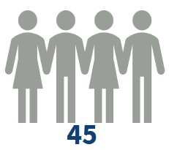West Nile virus disease human cases.
Sexes:
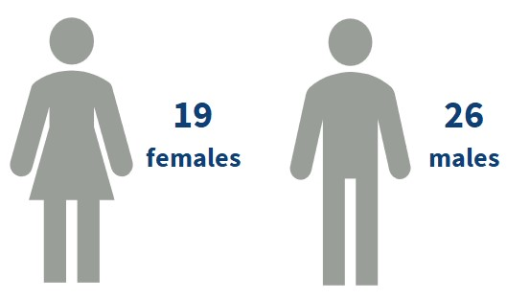
Ages:
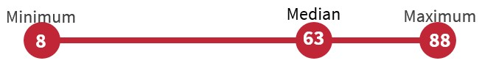
From 23 counties:
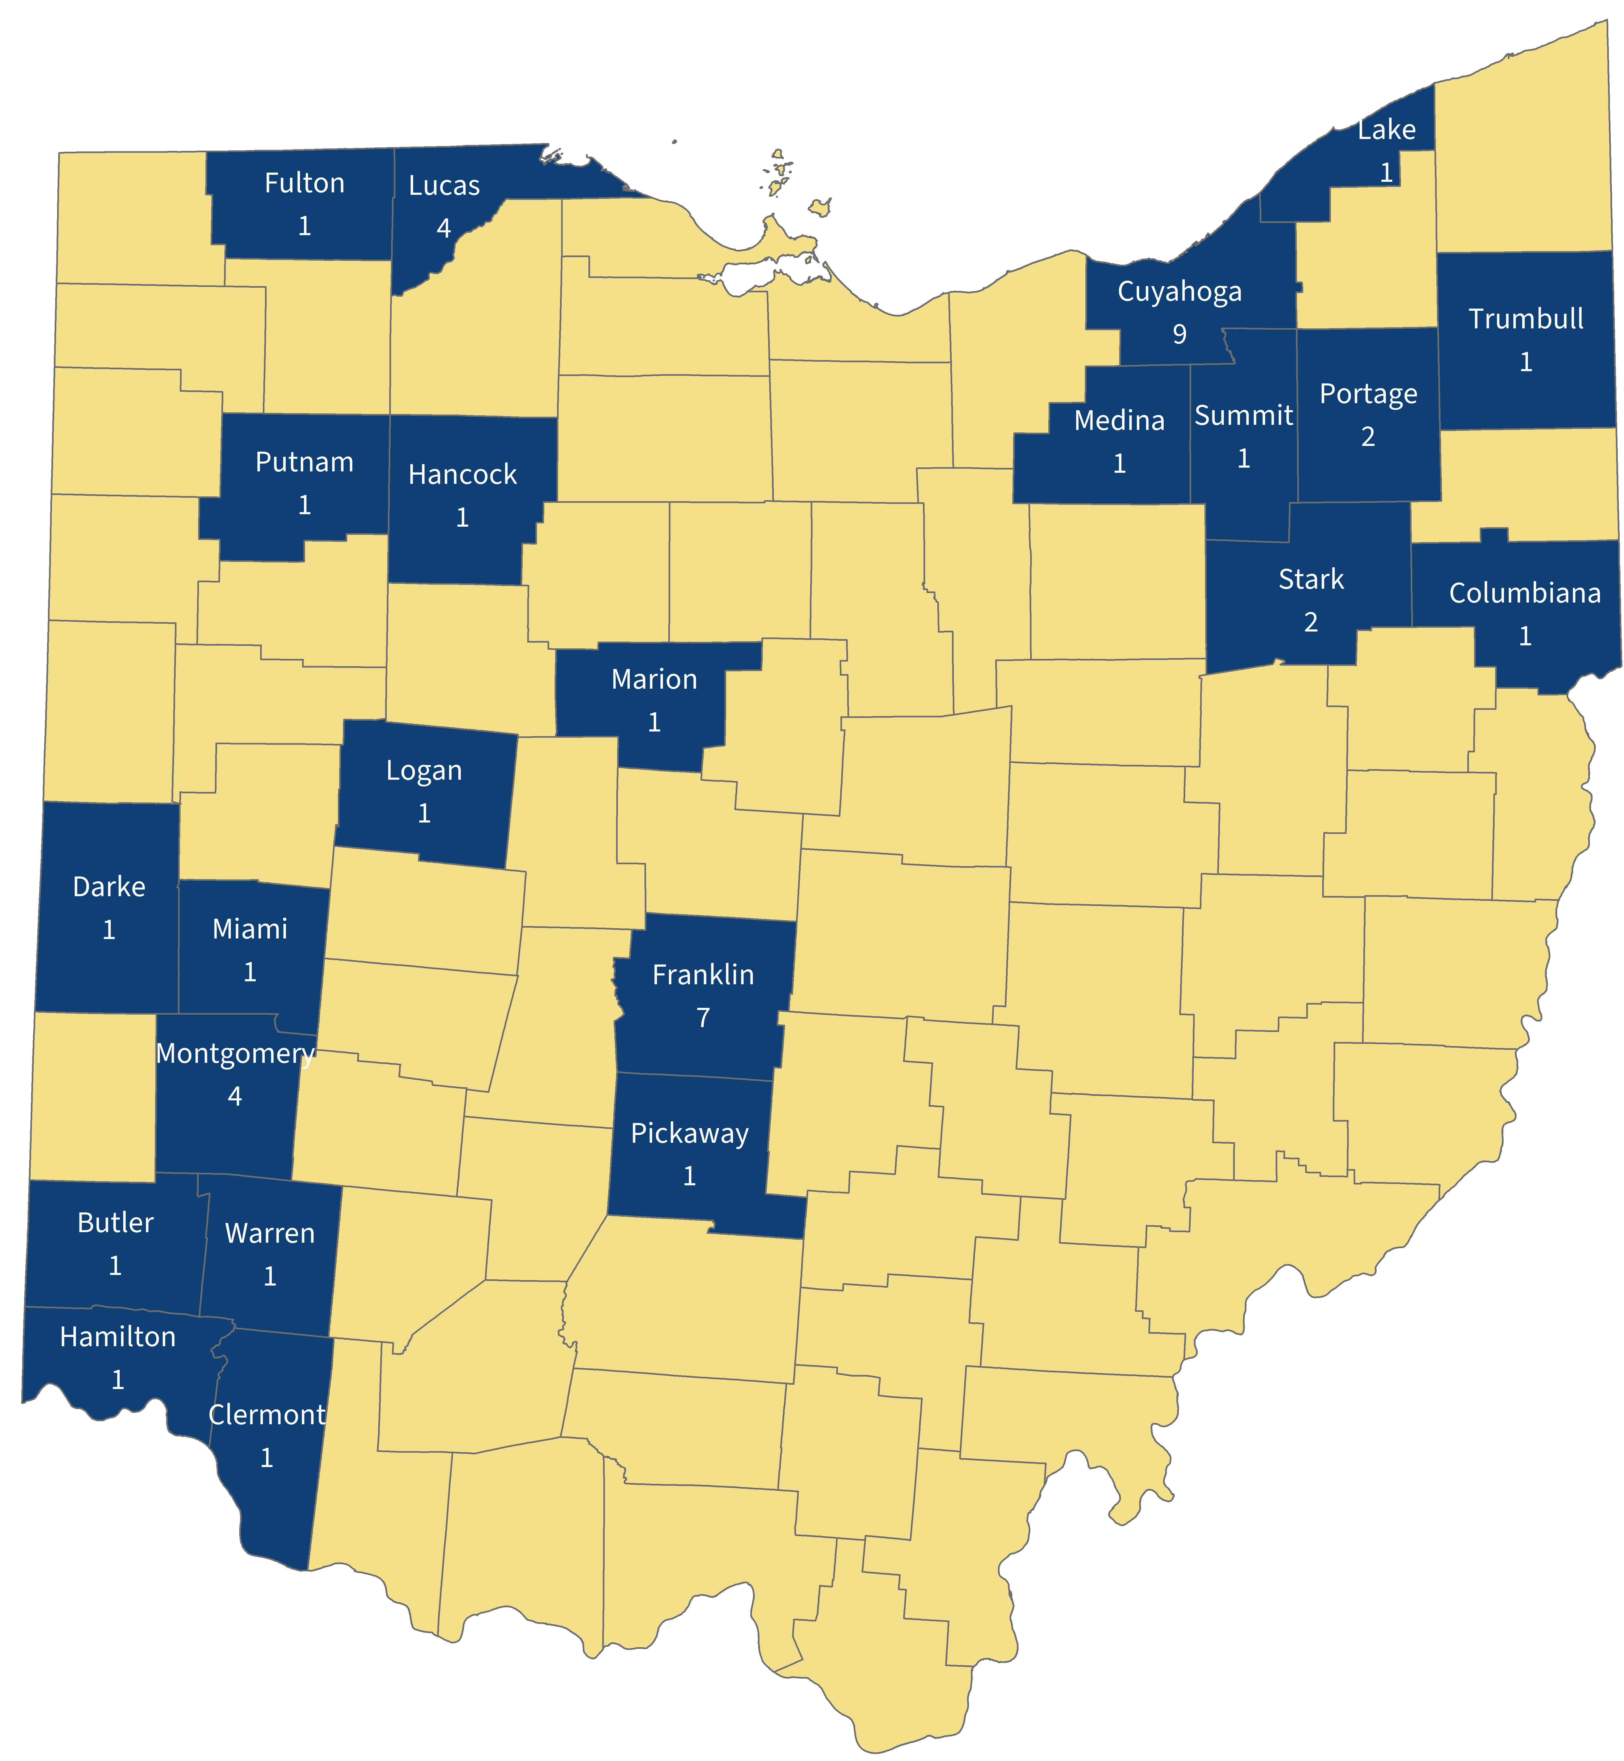
Butler (1), Clermont (1), Columbiana (1), Cuyahoga (9), Darke (1), Franklin (7), Fulton (1), Hamilton (1), Hancock (1), Lake (1), Logan (1), Lucas (4), Marion (1), Medina (1), Miami (1), Montgomery (4), Pickaway (1), Portage (2), Putnam (1), Stark (2), Summit (1), Trumbull (1), Warren (1).
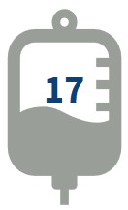Asymptomatic, viremic blood donors.
Veterinary surveillance:
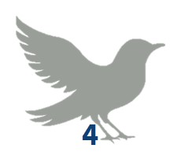West Nile virus avian cases.
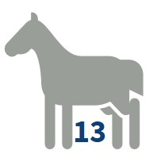West Nile virus equine cases.

La Crosse/California encephalitis virus
Mosquito surveillance:
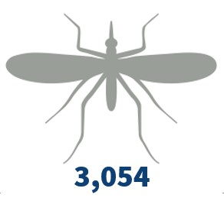
Mosquitoes tested from 53 agencies in 44 counties pooled into 1,297 samples.
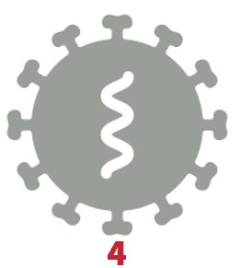
La Crosse virus positive mosquito pools from 4 counties:
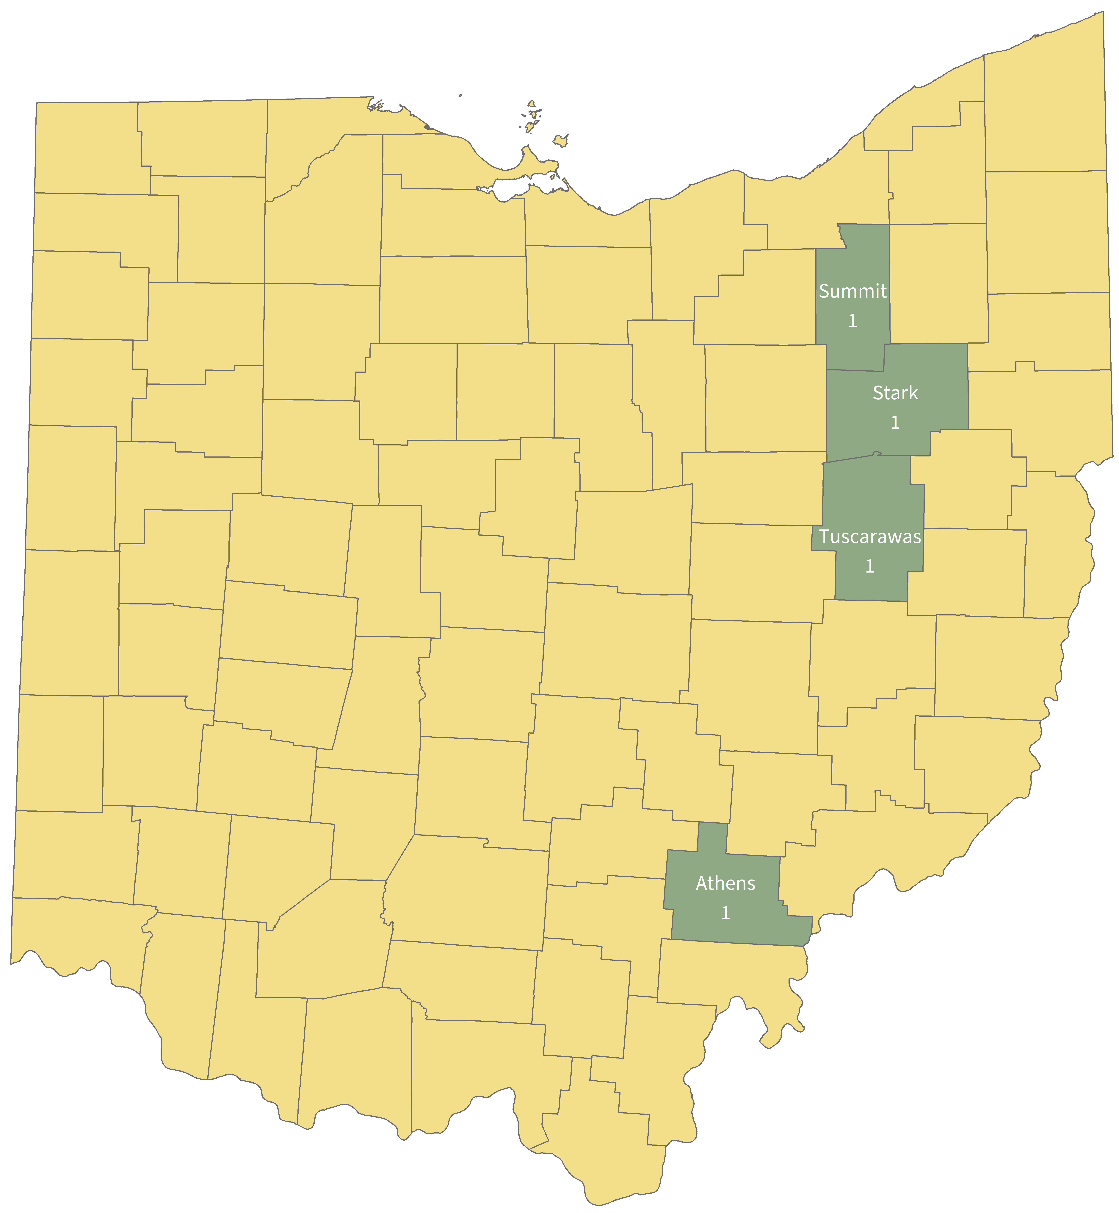
Athens (1), Stark (1), Summit (1), Tuscarawas (1).
Human surveillance:
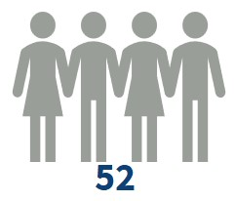La Crosse virus disease human cases.
Sexes:
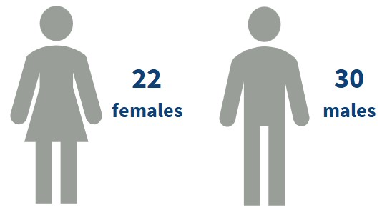
Ages:
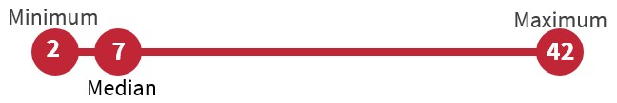
From 29 counties:
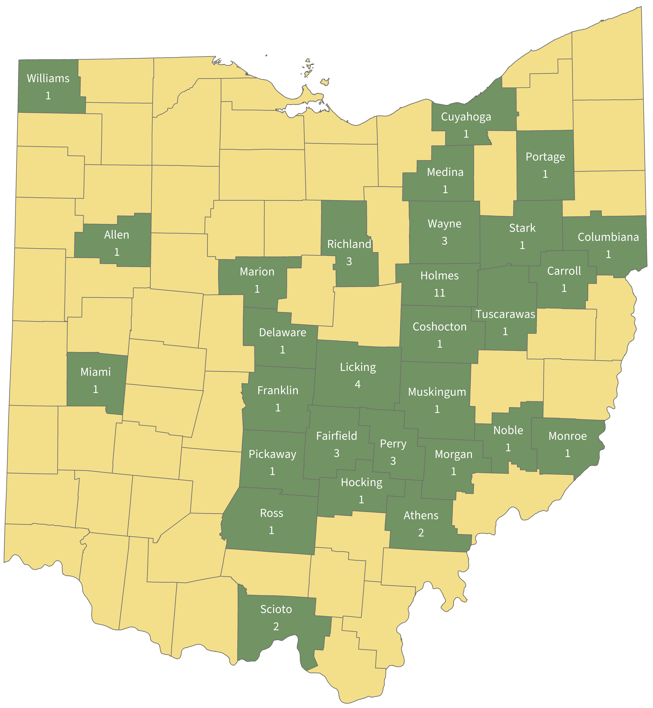
Allen (1), Athens (2), Carroll (1), Columbiana (1), Coshocton (1), Cuyahoga (1), Delaware (1), Fairfield (3), Franklin (1), Hocking (1), Holmes (11), Licking (4), Marion (1), Medina (1), Miami (1), Monroe (1), Morgan (1), Muskingum (1), Noble (1), Perry (3), Pickaway (1), Portage (1), Richland (3), Ross (1), Scioto (2), Stark (1), Tuscarawas (1), Wayne (3), Williams

Travel-associated mosquito-borne diseases
Chikungunya surveillance:
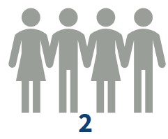Chikungunya human cases.
Sexes:
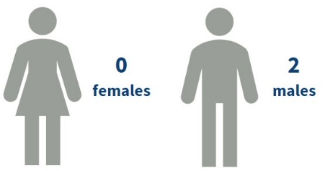
Ages:
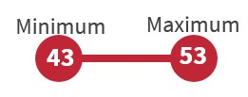
Traveled to 2 countries:
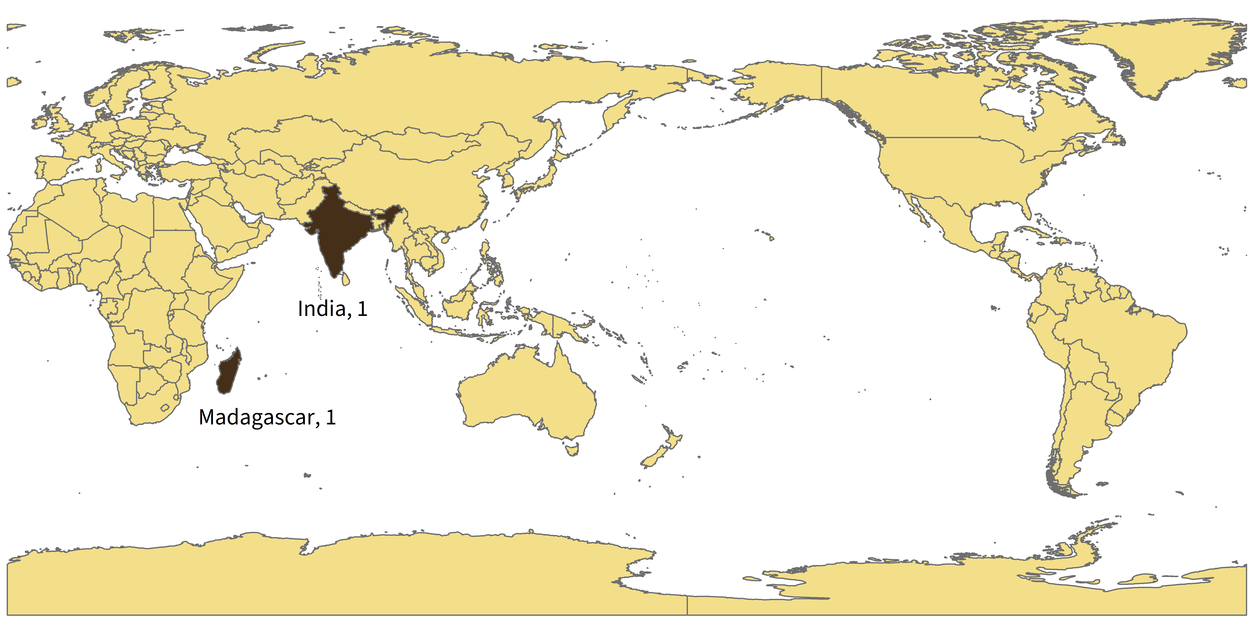
India (1), Madagascar (1).

Dengue surveillance:
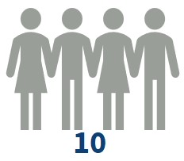Dengue human cases.
Sexes:
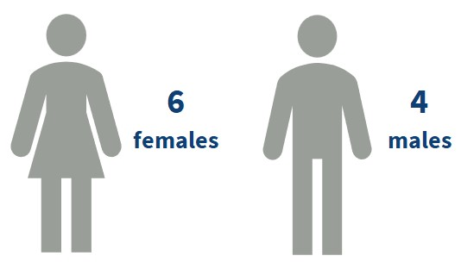
Ages:
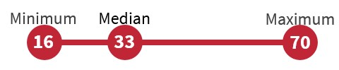
Traveled to 8 countries:
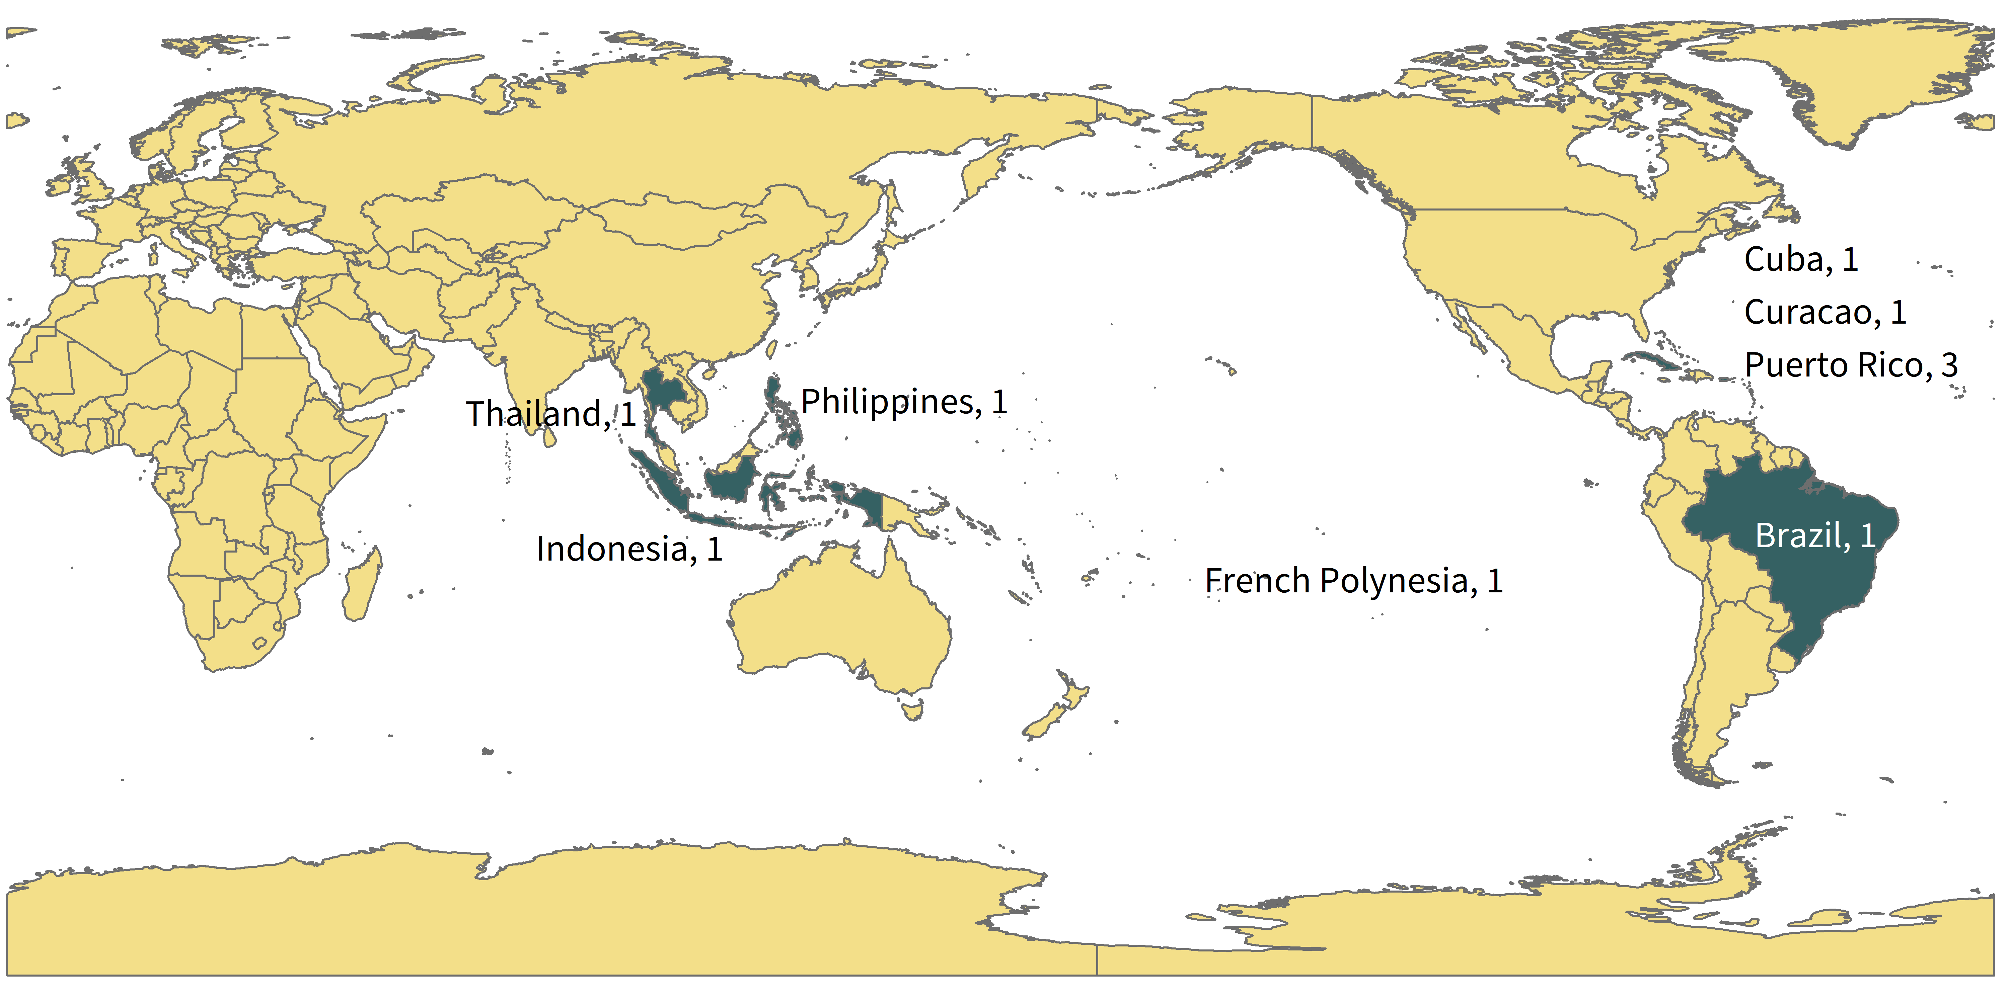
Brazil (1), Cuba (1), Curacao (1), French Polynesia (1), Indonesia (1), Philippines (1), Puerto Rico (3), Thailand (1).

Zika surveillance:
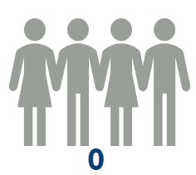Zika human cases.
Malaria surveillance:
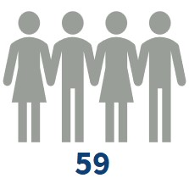Malaria human cases.
Sexes:
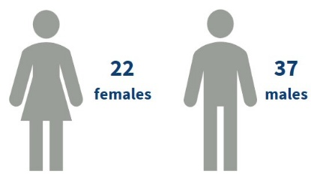
Ages:
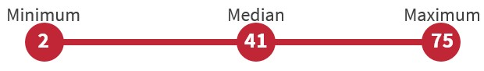
Traveled to 19 countries:
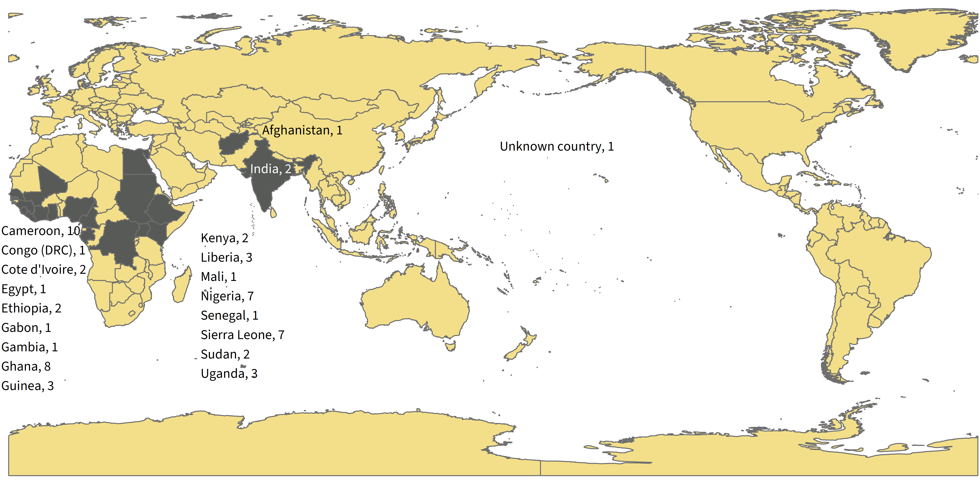
Afghanistan (1), Cameroon (10), Congo DRC (1), Cote d’Ivoire (2), Egypt (1), Ethiopia (2), Gabon (1), Gambia (1), Ghana (8), Guinea (3), India (2), Kenya (2), Liberia (3), Mali (1), Nigeria (7), Senegal (1), Sierra Leone (7), Sudan (2), Uganda (3), unknown country (1).
* Ohioans traveling to areas where local transmission is occurring should be aware of the ongoing situation and make every effort to avoid mosquito bites. Additional information can be found from the Centers for Disease Control and Prevention (CDC)'s Travelers' Health and Pan-American Health Organization websites.
2025 Tickborne Diseases

Lyme disease, anaplasmosis, babesiosis
Tick surveillance:
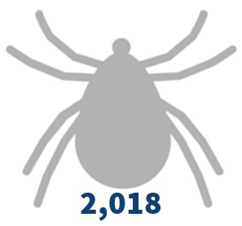Blacklegged ticks identified.

From 68 counties:
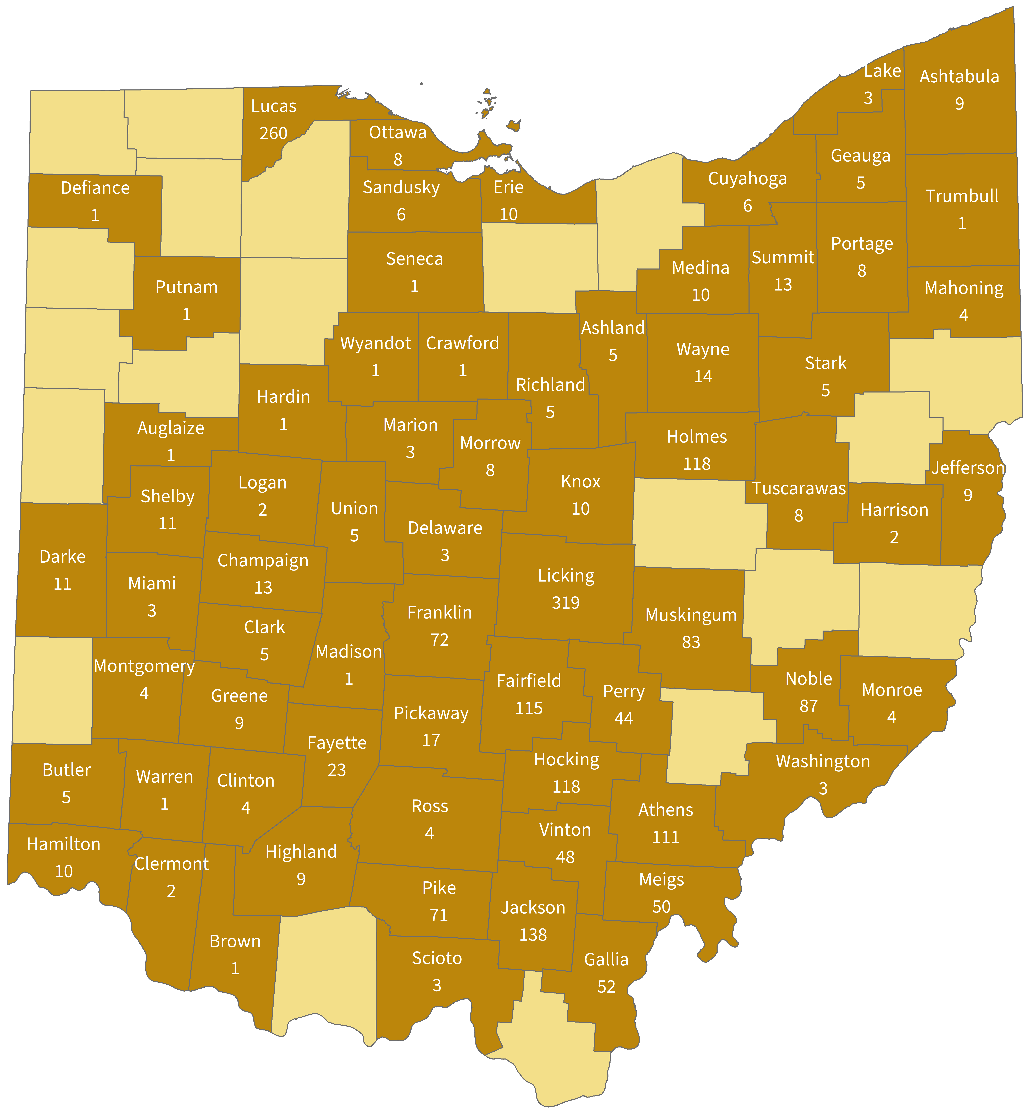
Ashland (5), Ashtabula (9), Athens (111), Auglaize (1), Brown (1), Butler (5), Champaign (13), Clark (5), Clermont (2), Clinton (4), Crawford (1), Cuyahoga (6), Darke (11), Defiance (1), Delaware (3), Erie (10), Fairfield (115), Fayette (23), Franklin (72), Gallia (52), Geauga (5), Greene (9), Hamilton (10), Hardin (1), Harrison (2), Highland (9), Hocking (118), Holmes (118), Jackson (138), Jefferson (9), Knox (10), Lake (3), Licking (319), Logan (2), Lucas (260), Madison (1), Mahoning (4), Marion (3), Medina (10), Meigs (50), Miami (3), Monroe (4), Montgomery (4), Morrow (8), Muskingum (83), Noble (87), Ottawa (8), Perry (44), Pickaway (17), Pike (71), Portage (8), Putnam (1), Richland (5), Ross (4), Sandusky (6), Scioto (3), Seneca (1), Shelby (11), Stark (5), Summit (13), Trumbull (1), Tuscarawas (8), Union (5), Vinton (48), Warren (1), Washington (3), Wayne (14), Wyandot (1), unknown (20).

Lyme disease human surveillance:
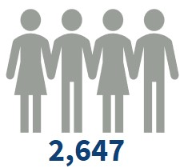Lyme disease human cases.
Sexes:
\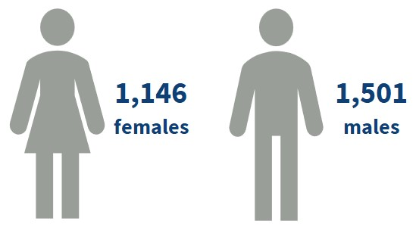
Ages:
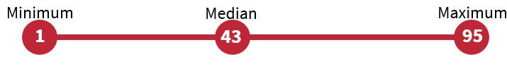
From 72 counties:
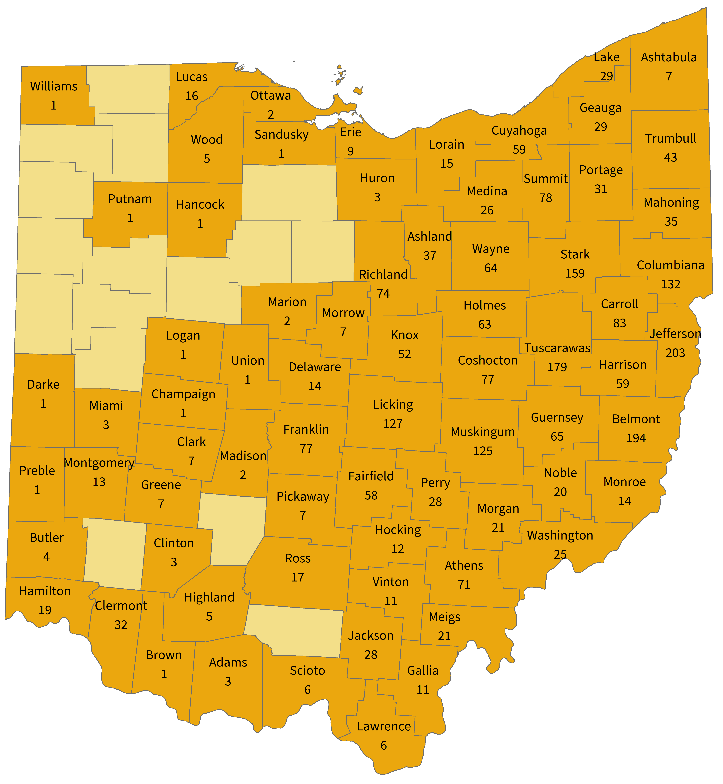
Adams (3), Ashland (37), Ashtabula (7), Athens (71), Belmont (194), Brown (1), Butler (4), Carroll (83), Champaign (1), Clark (7), Clermont (32), Clinton (3), Columbiana (132), Coshocton (77), Cuyahoga (59), Darke (1), Delaware (14), Erie (9), Fairfield (58), Franklin (77), Gallia (11), Geauga (29), Greene (7), Guernsey (65), Hamilton (19), Hancock (1), Harrison (59), Highland (5), Hocking (12), Holmes (63), Huron (3), Jackson (28), Jefferson (203), Knox (52), Lake (29), Lawrence (6), Licking (127), Logan (1), Lorain (15), Lucas (16), Madison (2), Mahoning (35), Marion (2), Medina (26), Meigs (21), Miami (3), Monroe (14), Montgomery (13), Morgan (21), Morrow (7), Muskingum (125), Noble (20), Ottawa (2), Perry (28), Pickaway (7), Portage (31), Preble (1), Putnam (1), Richland (74), Ross (17), Sandusky (1), Scioto (6), Stark (159), Summit (78), Trumbull (43), Tuscarawas (179), Union (1), Vinton (11), Washington (25), Wayne (64), Williams (1), Wood (5), unknown county (3).

Anaplasmosis human surveillance:
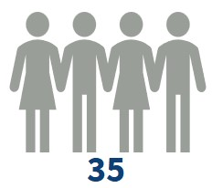Anaplasmosis human cases.
Sexes:
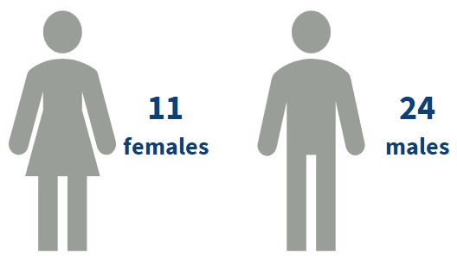
Ages:
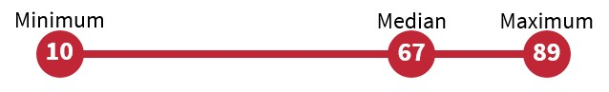
From 20 counties:
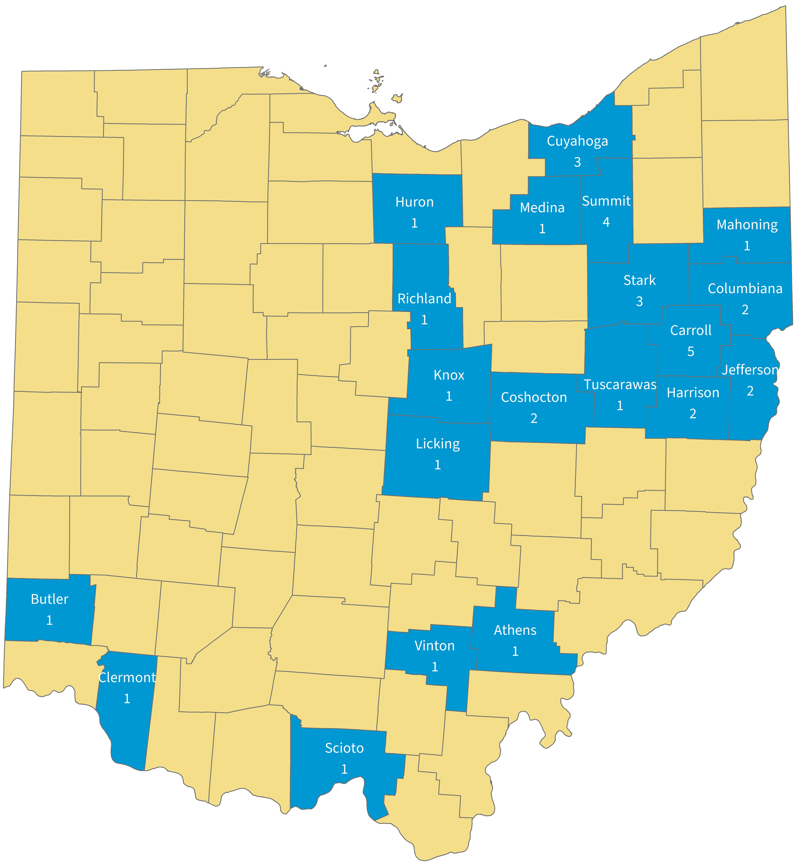
Athens (1), Butler (1), Carroll (5), Clermont (1), Columbiana (2), Coshocton (2), Cuyahoga (3), Harrison (2), Huron (1), Jefferson (2), Knox (1), Licking (1), Mahoning (1), Medina (1), Richland (1), Scioto (1), Stark (3), Summit (4), Tuscarawas (1), Vinton (1)..

Babesiosis human surveillance:
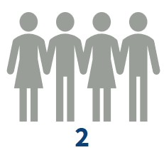Babesiosis human cases.
Sexes:
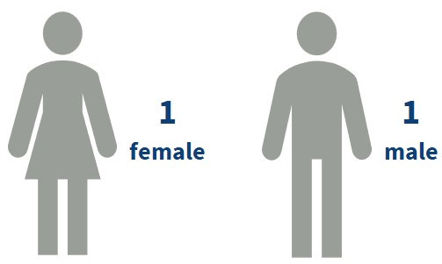
Ages:
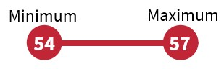
From 2 counties:
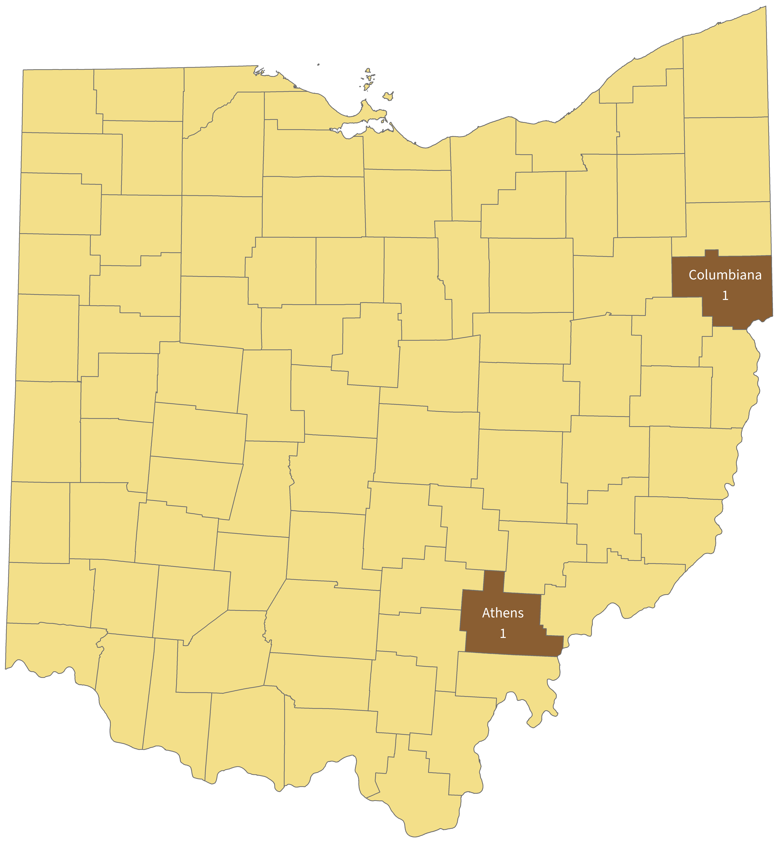
Athens (1), Columbiana (1).

Rocky Mountain spotted fever (RMSF)
Tick surveillance:
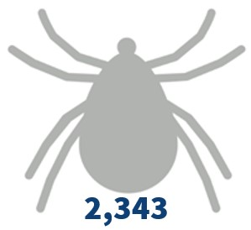American dog ticks identified.
Human surveillance:
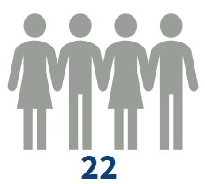RMSF human cases.
Sexes:
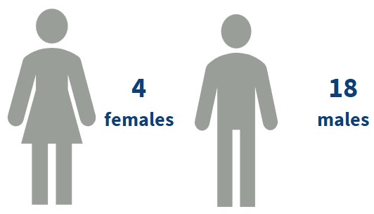
Ages:
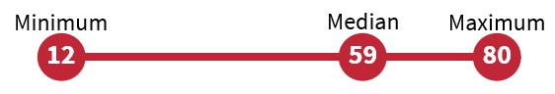
From 14 counties:
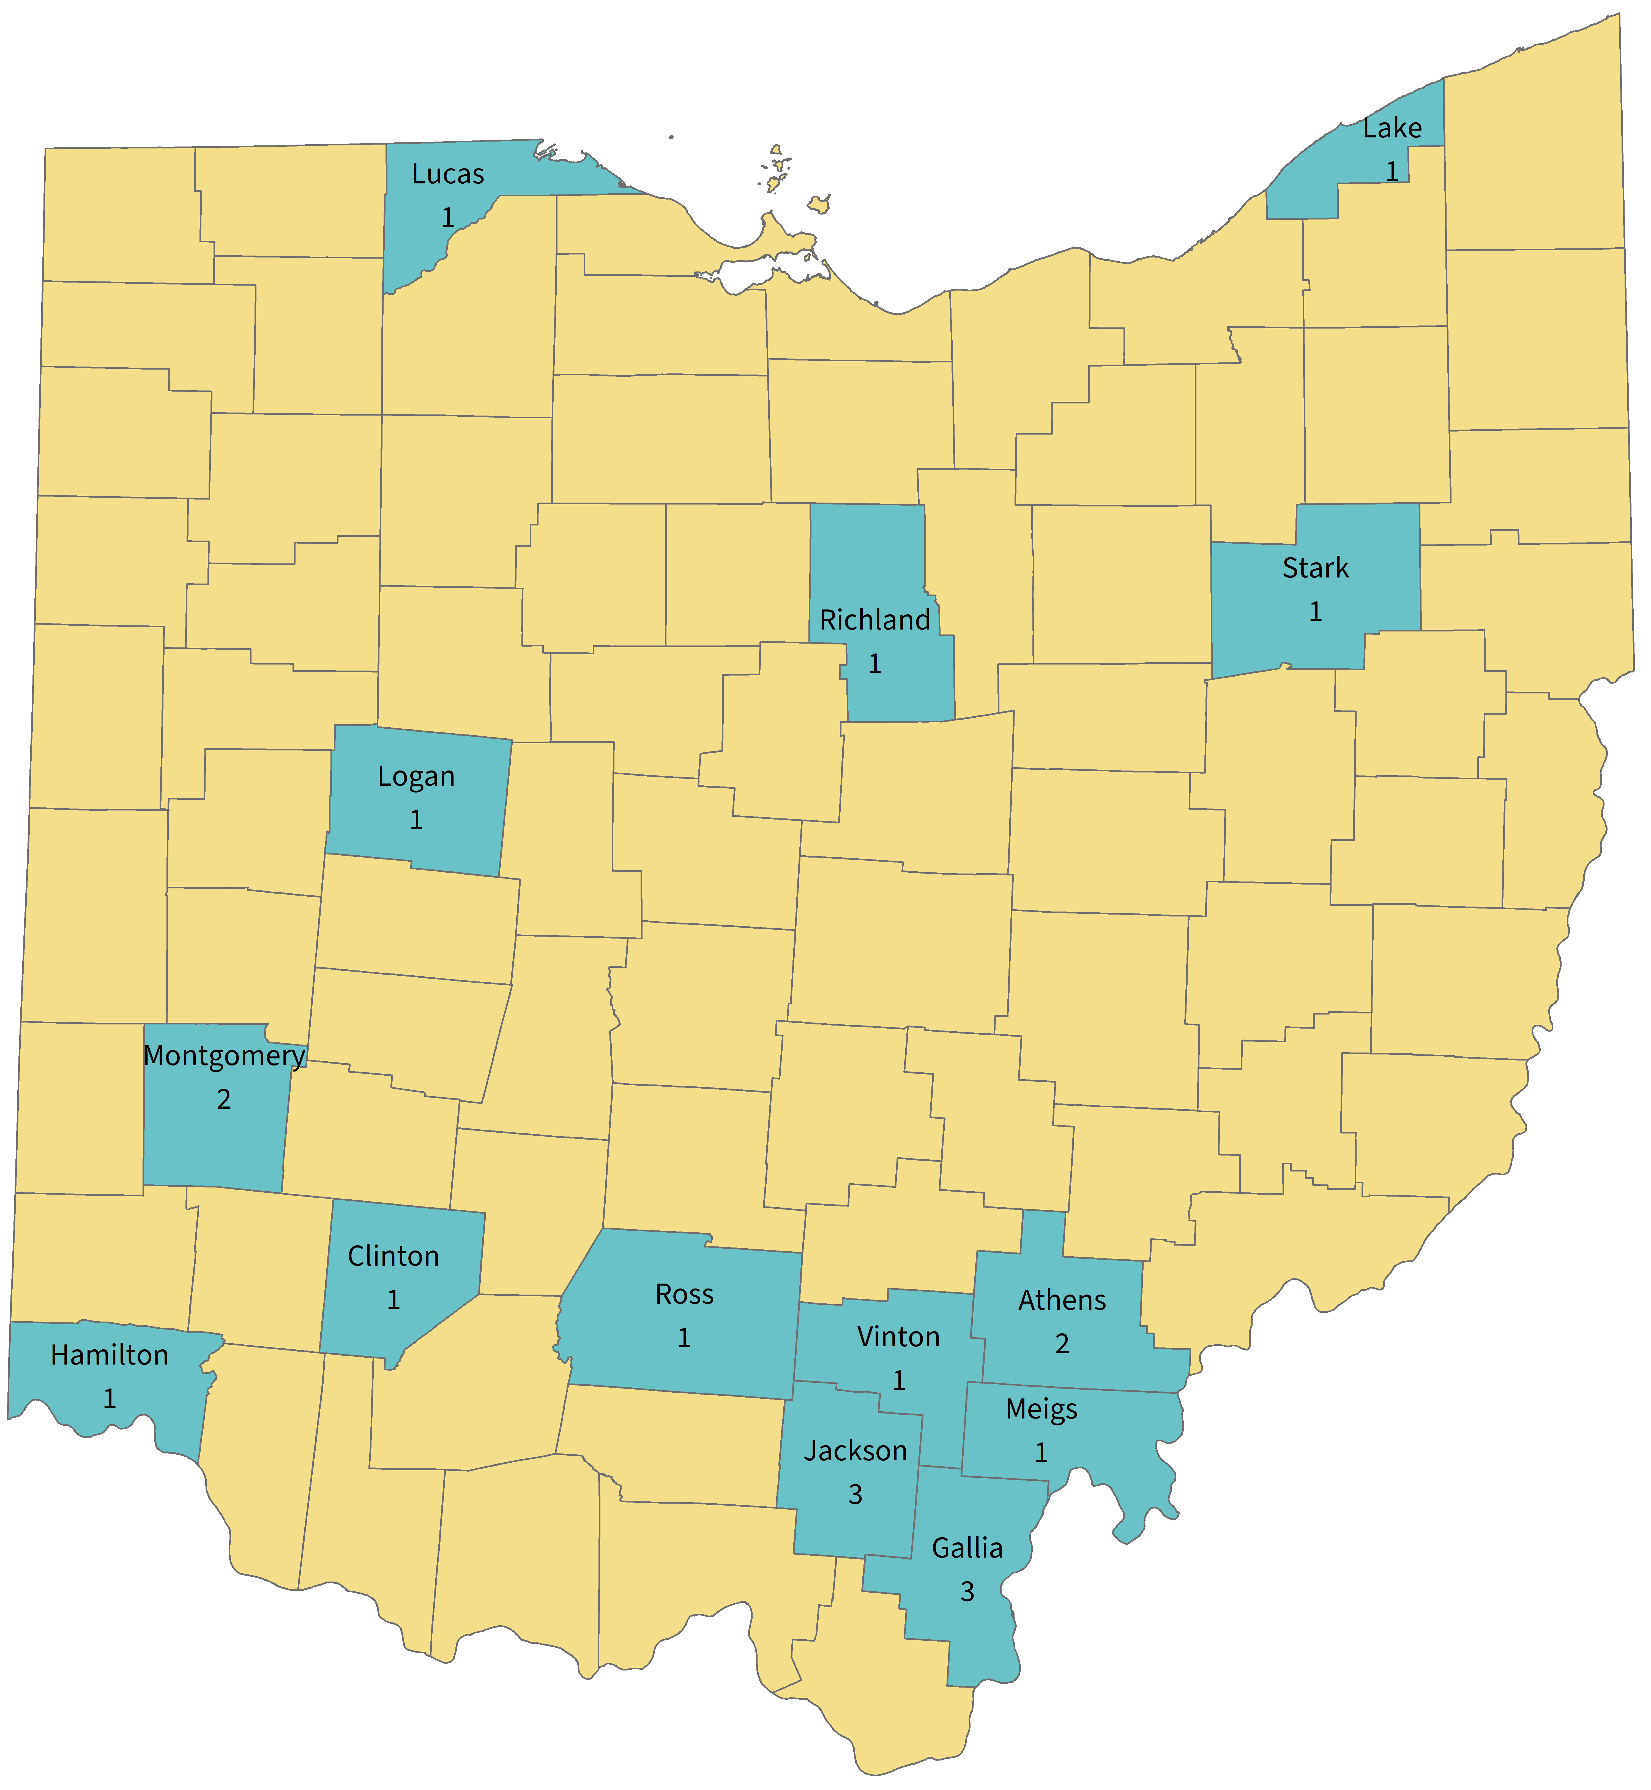
Athens (2), Clinton (1), Gallia (3), Hamilton (2), Jackson (3), Lake (1), Logan (1), Lucas (1), Meigs (1), Montgomery (2), Richland (1), Ross (1), Stark (1), Vinton (2).

Ehrlichiosis
Tick surveillance:
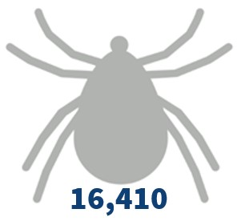Lone Star ticks identified.
Human surveillance:
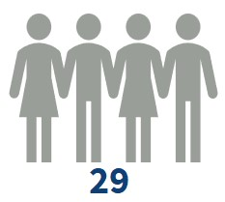Ehrlichiosis human cases.
Sexes:
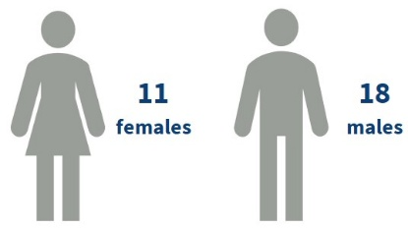
Ages:
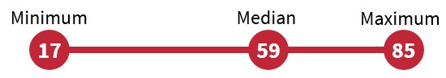
From 16 counties:
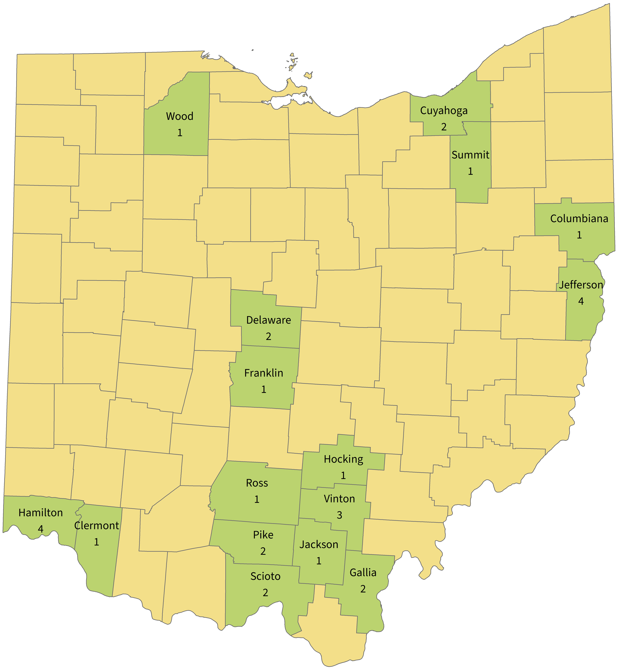
Clermont (1), Columbiana (1), Cuyahoga (2), Delaware (2), Franklin (1), Gallia (2), Hamilton (4), Hocking (1), Jackson (1), Jefferson (4), Pike (2), Ross (1), Scioto (2), Summit (1), Vinton (3), Wood (1).

